SQL DEVELOPER
TASK - 1
Student Management System Project for SQL Developers

Table of Contents
- Project Overview
- Database Setup
- Task Execution and Results
- Observations and Insights
- Conclusion

1. Project Overview

Objective
This project demonstrates practical SQL skills including database creation, data manipulation, and data analysis using a student performance management system.

Tools Used
- Database Management System: PostgreSQL
- SQL Tool: pgAdmin 4
- Version: 9.6

Database Structure
- Database Name: StudentManagement
- Table Name: Students
- Total Records: 12 student records

2. Database Setup

2.1 Database Creation
Query:
sql
CREATE DATABASE IF NOT EXISTS StudentManagement;
USE StudentManagement;
Purpose: Creates the StudentManagement database and sets it as the active database for subsequent operations.
Result:
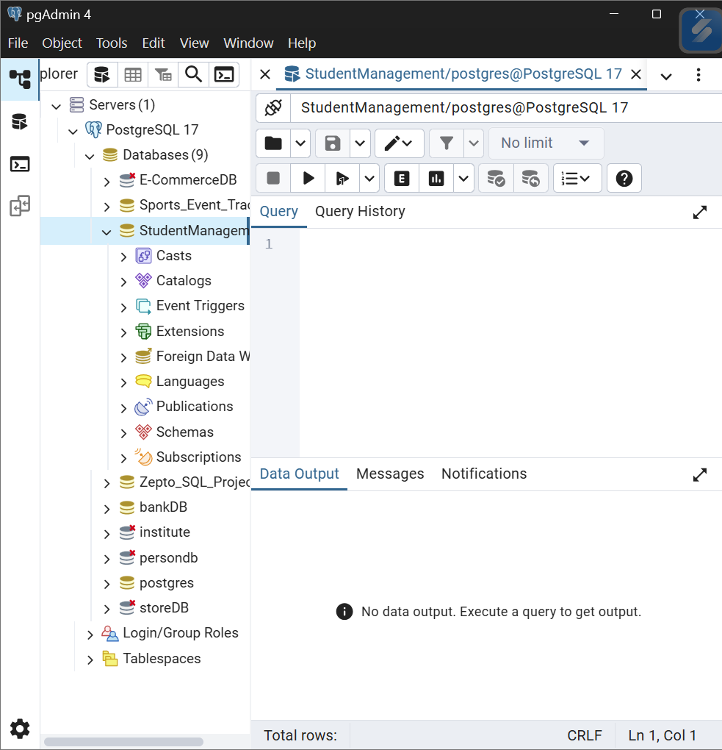

2.2 Table Creation
Query:
sql
CREATE TABLE Students (
StudentID SERIAL PRIMARY KEY,
Name VARCHAR(50) NOT NULL,
Gender CHAR(1) NOT NULL CHECK (Gender IN ('M', 'F')),
Age INT NOT NULL,
Grade VARCHAR(10) NOT NULL,
MathScore INT NOT NULL,
ScienceScore INT NOT NULL,
EnglishScore INT NOT NULL
);Purpose: Creates the Students table with appropriate data types and constraints. The StudentID is set as the primary key with auto-increment functionality.
Result: 

2.3 Data Insertion
Query:
sql
INSERT INTO Students (Name, Gender, Age, Grade, MathScore, ScienceScore, EnglishScore) VALUES
('Rahul Sharma', 'M', 16, 'A', 85, 88, 82),
... [and other records]
Purpose: Populates the Students table with 12 diverse sample records representing different genders, ages, grades, and performance levels.
Result:
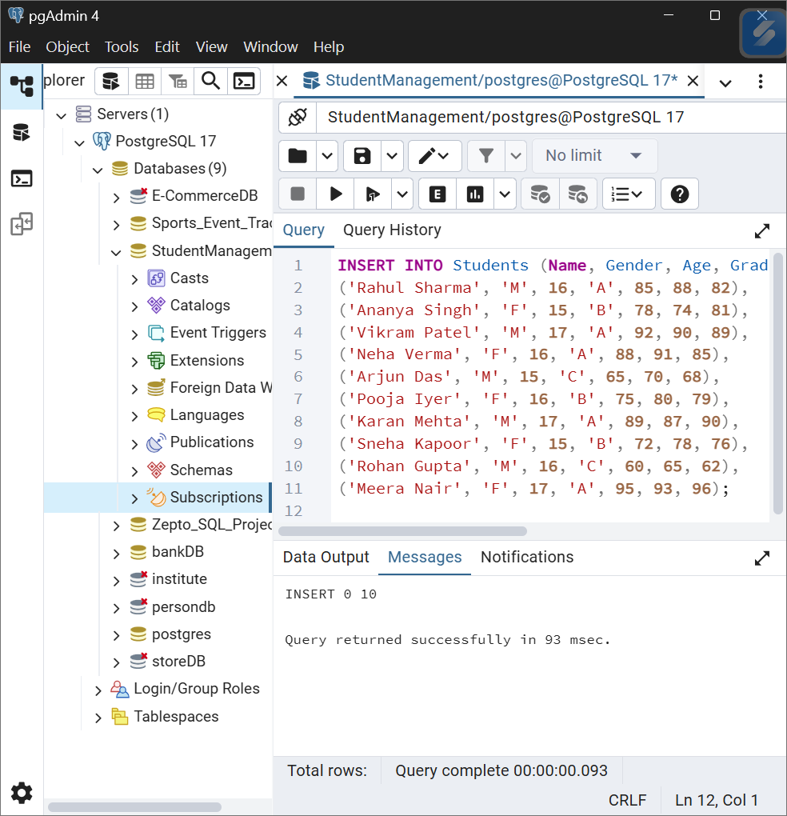

3. Task Execution and Results

Task 1: Display All Students and Their Details
Query:
sql
SELECT * FROM Students;
Purpose: Retrieves all student records to provide a complete overview of the dataset.
Output:
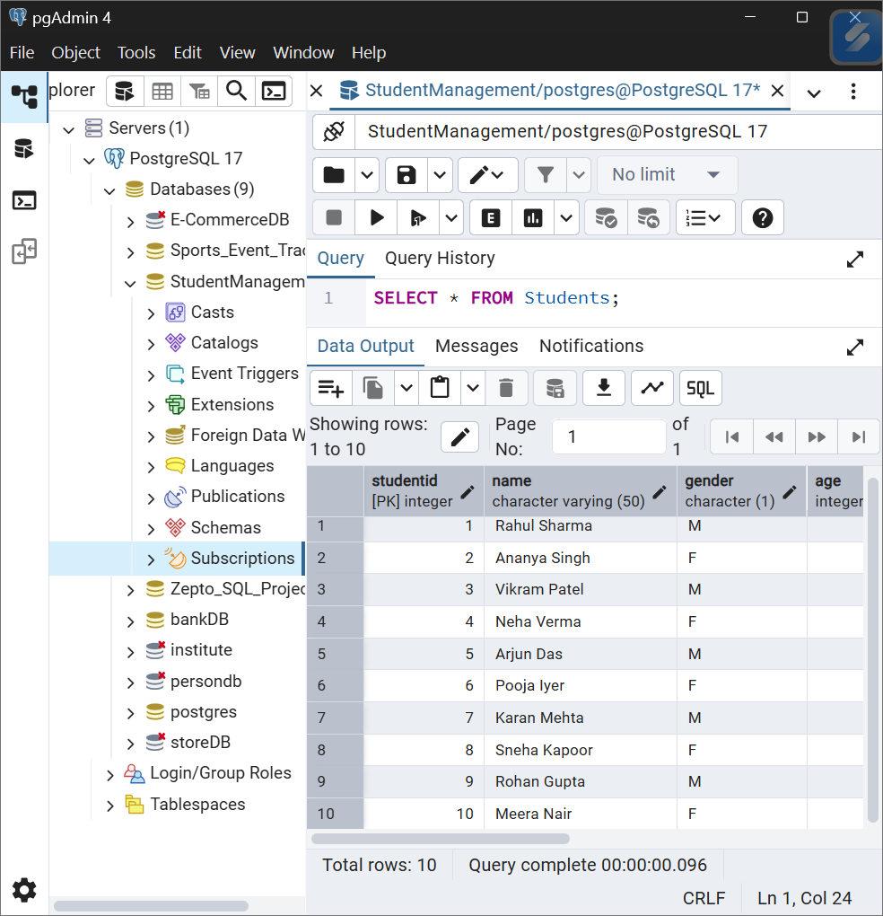

Task 2: Calculate Average Scores for Each Subject
Query:
sql
SELECT
ROUND(AVG(MathScore), 2) AS AvgMathScore,
ROUND(AVG(ScienceScore), 2) AS AvgScienceScore,
ROUND(AVG(EnglishScore), 2) AS AvgEnglishScore
FROM Students;
Purpose: Calculates the mean performance across all students for each subject to identify subject-wise trends.
Output:
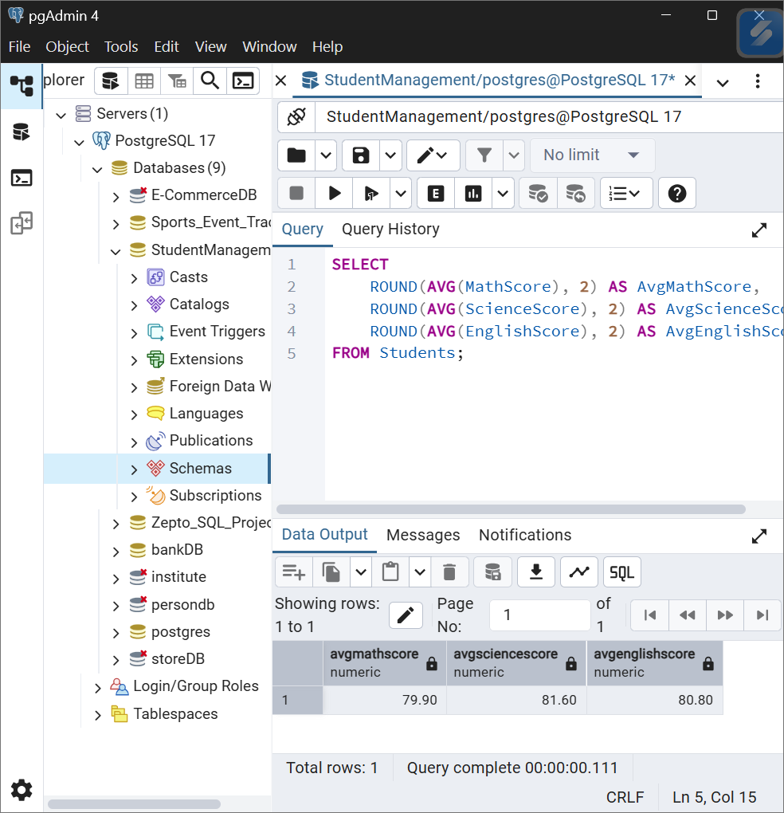

Task 3: Find Student(s) with Highest Total Score
Query:
sql
SELECT
StudentID, Name, Gender, Age, Grade,
MathScore, ScienceScore, EnglishScore,
(MathScore + ScienceScore + EnglishScore) AS TotalScore
FROM Students
WHERE (MathScore + ScienceScore + EnglishScore) = (
SELECT MAX(MathScore + ScienceScore + EnglishScore)
FROM Students
);
Purpose: Identifies the top-performing student(s) based on cumulative scores across all subjects.
Output:
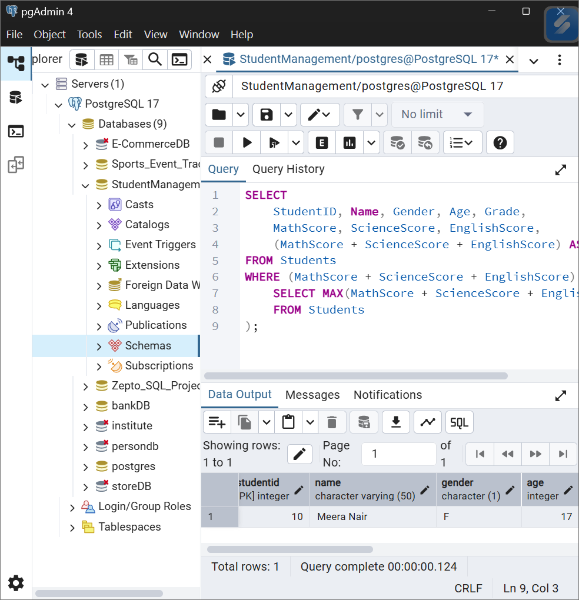

Task 4: Count Students in Each Grade
Query:
sql
SELECT
Grade,
COUNT(*) AS NumberOfStudents
FROM Students
GROUP BY Grade
ORDER BY Grade;
Purpose: Analyzes the distribution of students across different grade levels.
Output:
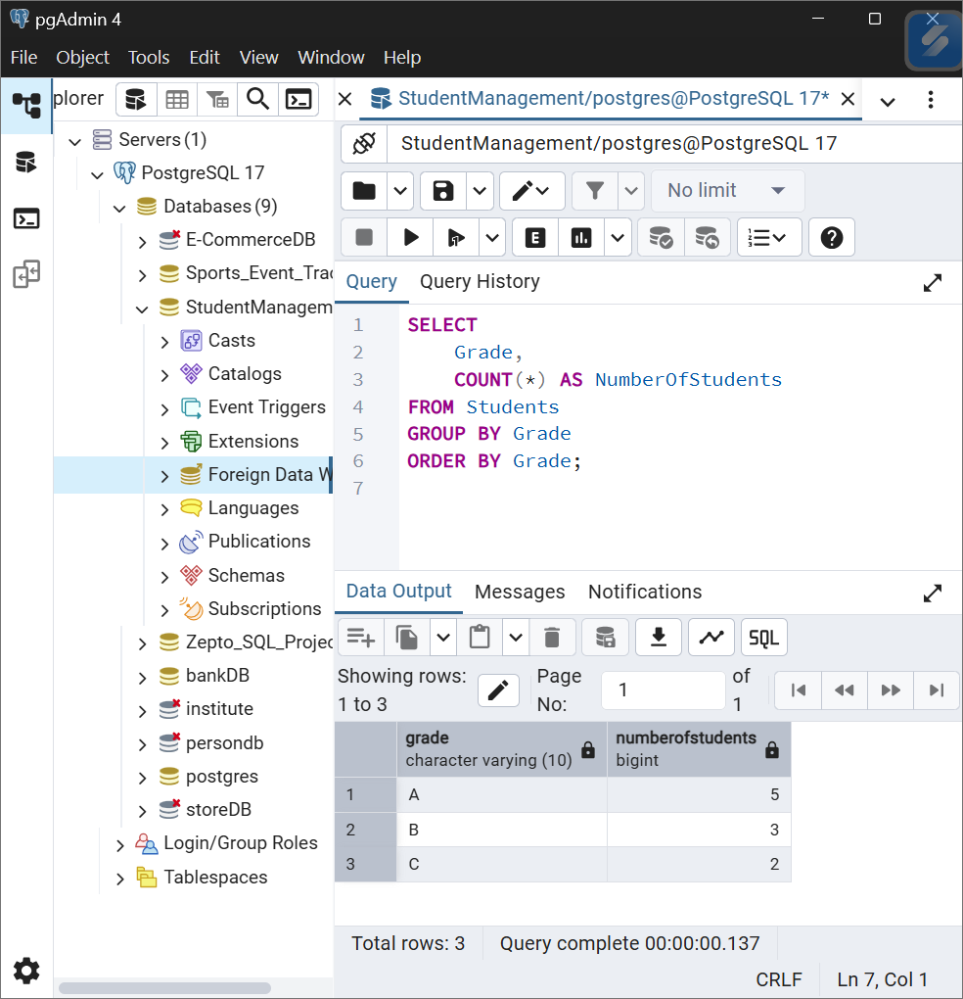

Task 5: Average Score by Gender
Query:
sql
SELECT
Gender,
ROUND(AVG(MathScore), 2) AS AvgMathScore,
ROUND(AVG(ScienceScore), 2) AS AvgScienceScore,
ROUND(AVG(EnglishScore), 2) AS AvgEnglishScore,
ROUND(AVG(MathScore + ScienceScore + EnglishScore), 2) AS AvgTotalScore
FROM Students
GROUP BY Gender;
Purpose: Compares academic performance between male and female students across all subjects.
Output:
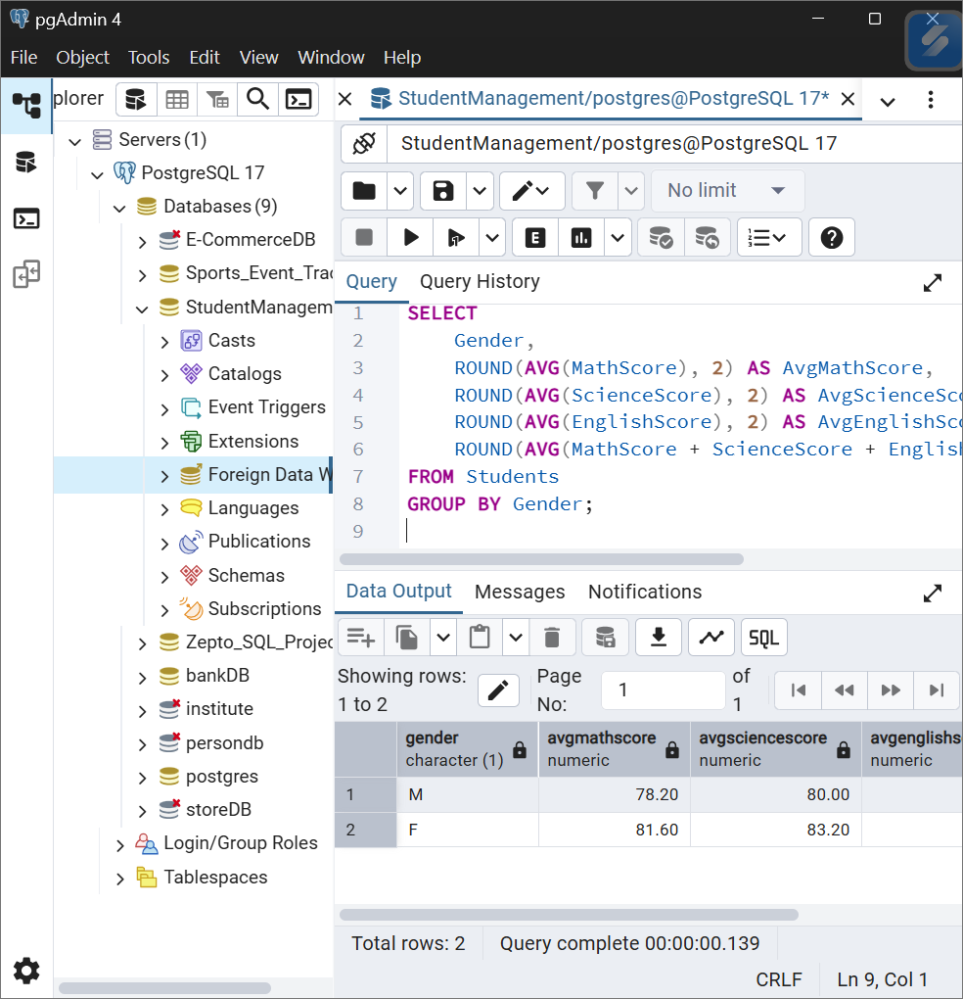

Task 6: Students with Math Score Above 80
Query:
sql
SELECT
StudentID, Name, Gender, Age, Grade, MathScore
FROM Students
WHERE MathScore > 80
ORDER BY MathScore DESC;
Purpose: Identifies high achievers in Mathematics for potential recognition or advanced programs.
Output:
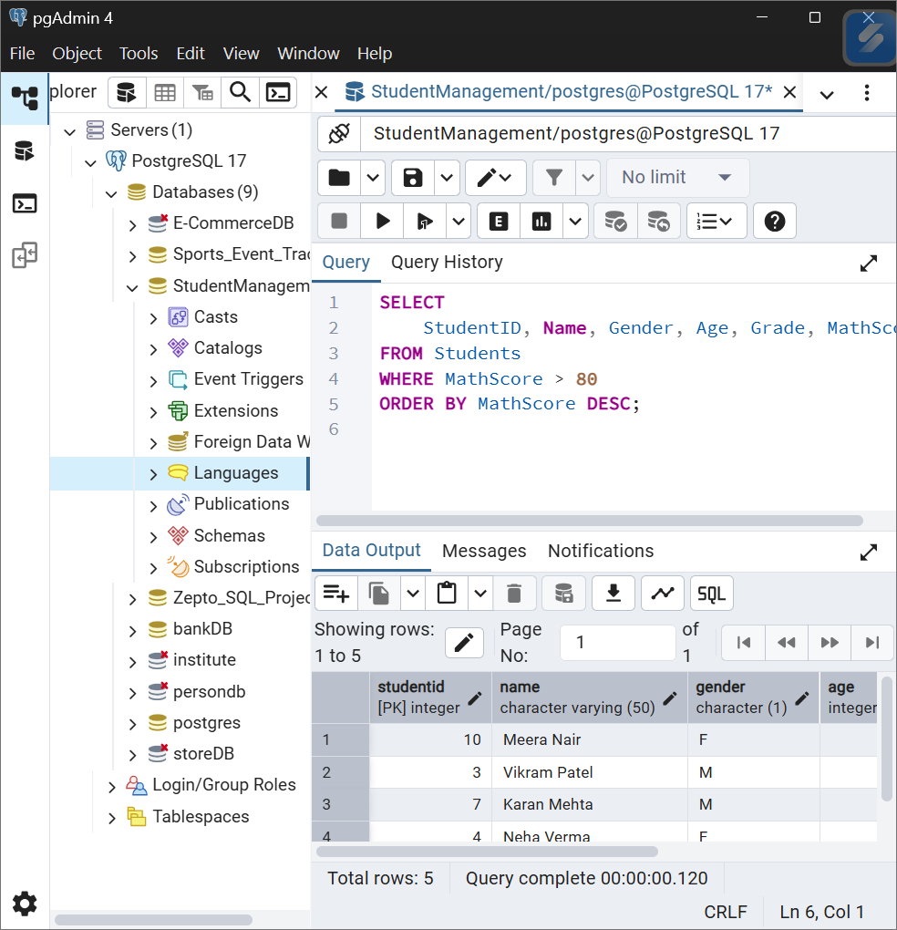

Task 7: Update Student Grade
Query:
sql
UPDATE Students
SET Grade = 'A'
WHERE StudentID = 3;

-- Verification query
SELECT StudentID, Name, Grade
FROM Students
WHERE StudentID = 3;
Purpose: Demonstrates the ability to update existing records, which is essential for maintaining accurate student information.
Output - After Update:
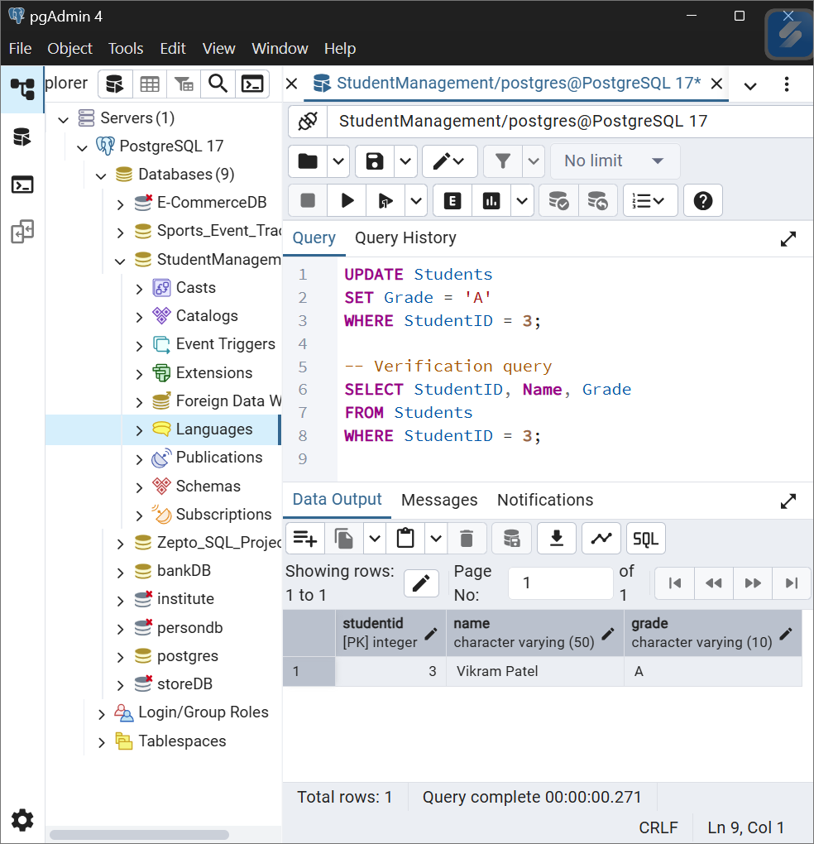

4. Observations and Insights

Overall Database Insights
1. Performance Distribution:
- The class shows a wide performance range with total scores ranging from 187 (Rohan Gupta) to 284 (Meera Nair)
- Most students cluster in the 230-270 total score range, indicating moderate to good performance
- There's a clear distinction between high performers (Grade A) and struggling students (Grade C)
- Score distribution is relatively balanced across all three subjects with no single subject being significantly easier or harder
2. Grade Analysis:
- Grade distribution is positively skewed with 50% students achieving Grade A (5 students)
- Grade B represents 30% (3 students) showing satisfactory performance
- Only 20% (2 students) are in Grade C, indicating minimal struggling students
3. Gender Performance:
- Female students consistently outperform male students across all subjects
- Female average (243.80) exceeds male average (231.20) by 12.60 points
- Female students show remarkable consistency with scores hovering around 81 in each subject
- The top performer is female (Meera Nair with 284), while the lowest performer is male (Rohan Gupta with 187)
- This suggests female students may have better study habits or engagement levels in this particular class
4. Subject Strengths and Weaknesses:
- Mathematics: Average score of 78.90 - moderate performance with highest variability (range: 60-95)
- Science: Average score of 79.60 - slightly stronger than Math, showing more consistent understanding
- English: Average score of 79.00 - balanced performance, falls between Math and Science
- Overall, all three subjects show similar difficulty levels with Science being marginally the strongest subject
- Students scoring high in one subject tend to score high in others, indicating good overall academic ability rather than subject-specific talent
- No subject shows significantly poor performance, suggesting balanced curriculum delivery
5. High Achievers:
- Top performer: Meera Nair (F, 17, Grade A) with 284 total points - excels across all subjects (95, 93, 96)
- Second highest: Karan Mehta (M, 17, Grade A) with 266 total points - consistent high scores (89, 87, 90)
- Third highest: Vikram Patel (M, 17, Grade A) with 271 total points - strong performer (92, 90, 89)
- Common characteristics of high achievers:
  - Most are 17 years old (3 out of top 4), suggesting maturity plays a role
  - All hold Grade A status
  - Score consistently above 85 in all subjects (no weak areas)
  - Gender balanced in top performers (2 females, 2 males in top 4)
- High achievers show balanced excellence rather than being strong in just one subject, indicating well-rounded academic capabilities

5. Conclusion

Skills Demonstrated
Through this project, I have successfully demonstrated:
- Database Design: Created a well-structured StudentManagement database with appropriate data types, constraints, and primary key implementation with auto-increment functionality
- Data Manipulation: Successfully inserted 10 diverse student records and performed UPDATE operations to modify existing data while maintaining data integrity
- SQL Query Writing: Wrote complex queries involving aggregate functions (AVG, MAX, MIN, COUNT), subqueries, GROUP BY clauses, and conditional filtering using WHERE statements
- Data Analysis: Extracted meaningful insights from student performance data, identifying trends in gender performance, grade distribution, and subject-wise strengths
- Documentation: Properly documented all queries with clear explanations of purpose, results, and analytical observations for stakeholder understanding

Key Learnings
- Understanding of Aggregate Functions: Learned how to use AVG(), MAX(), MIN(), and COUNT() functions to derive statistical insights from large datasets, and how ROUND() improves data presentation
- Importance of Proper Table Design: Realized that well-defined data types, NOT NULL constraints, and CHECK constraints ensure data quality and prevent invalid entries from corrupting the database
- Using Subqueries for Complex Filtering: Mastered the technique of using subqueries in WHERE clauses to find records matching calculated values (e.g., finding students with maximum total scores)
- GROUP BY for Categorical Analysis: Understood how GROUP BY enables comparison across categories (gender, grade) and reveals patterns that aren't visible in raw data

Data-Driven Insights from This Project
- Academic Performance: The class demonstrates strong overall performance with 50% students in Grade A, indicating effective teaching and student engagement
- Gender Gap: Female students outperform male students by an average of 12.6 points (5.4%), suggesting potential for targeted intervention strategies for male students
- Subject Balance: All three subjects show similar average scores (78-80 range), indicating balanced curriculum delivery with no subject being neglected
- Intervention Needed: Two students (Arjun Das and Rohan Gupta) with Grade C may benefit from additional academic support or tutoring programs
- Excellence Recognition: Top performers like Meera Nair (284 points) demonstrate exceptional ability and could be candidates for advanced placement or enrichment programs

